Cairo University Faculty of Computers and Information



**Software Engineering II**

**Daily scrum meeting template**

**2020**

**Project Team**

|  |  |  |  |
| --- | --- | --- | --- |
| **ID** | **Name** | **Email** | **Mobile** |
| 20170098 | Khaled Ezzat El-Hadary | khaledelhadary@outlook.com | 01276016539 |
| 20170093 | Hussien Ashraf Abdul-Hamid | [hussienashraf99@gmail.com](mailto:hussienashraf99@gmail.com) | 01016395068 |
| 20170085 | Hatem Mamdoh Said | matrix.leader@yahoo.com | 01016192209 |
| 20170072 | Ehap Fawzy Ibrahim | ehab1571999@yahoo.com | 01204860055 |

Contents

Done requirements 2

What will be done today 2

Current obstacles 2

Current Trello workspace 3

**Day 3**

# Done requirements

**Khaled: Finished sequence diagram of register normal user and store owner.**

**Hussien: Finished sequence diagram of showAllusers**

**Hatem: Finished sequence diagram of addAdmin**

**Ehab: Finished sequence diagram of login**

**Team: Created SDS and Project Skeleton**

# What will be done today

**Khaled: Implement database controller**

**Hussien: Implement user controller**

**Ehab: Implement user login, addAdmin & database table user**

**Hatem: Implement registerNormal & registerStoreOwner**

# Current obstacles

**Conflict between GitHub and local database because it has different names.**

**Some devices have problems with Visual Studio ASP.net.**

# 

# Current Trello workspace

* **Provide screen shot for your trello workspace**
* **Your screenshot should show product backlog (current requirements) and role of each members**

**Example:**

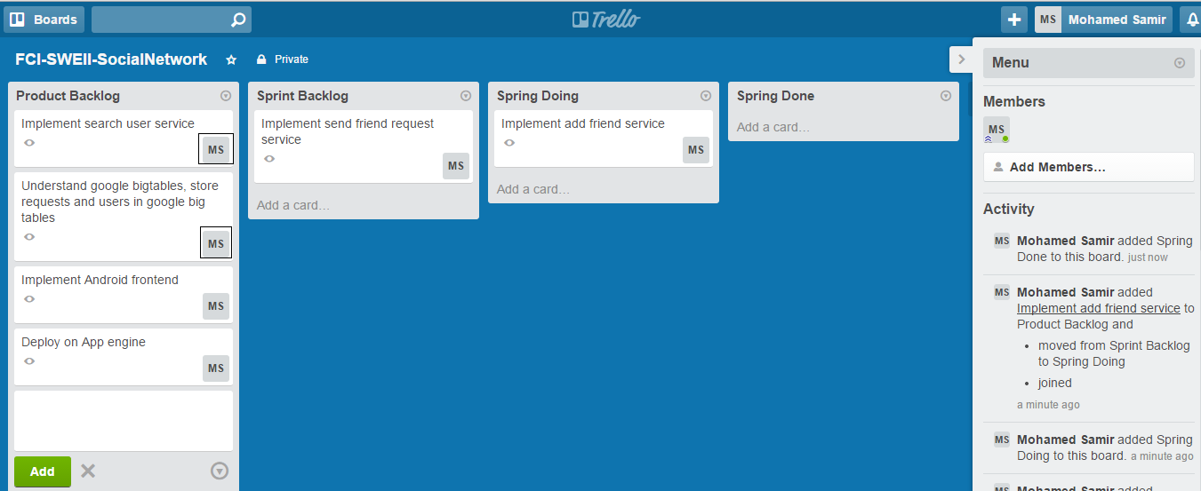

**Note black boxes which state who is responsible for each requirement**